* Presse-Info * Presse-Info * Presse-Info * Presse-Info * Presse-Info * Presse-Info *

www.rosenberger.com Fridolfing, February 2025

High-Precision Test Equipment for Automotive Connectors
With increasing demands on data transmission in vehicles, the need for precise test solutions is growing. Rosenberger presents high-precision test equipment for automotive connectors that reliably qualifies and secures high-speed data connections.

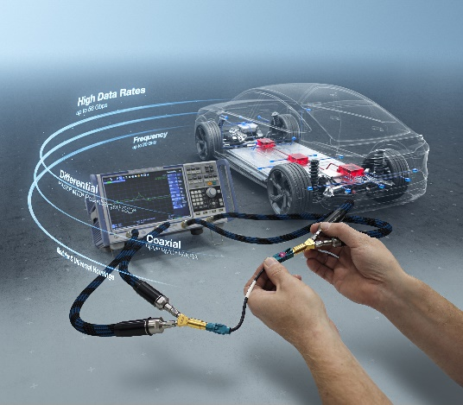
Innovative Solutions for High-Speed Data Transmission
The increasing networking of vehicles requires high-performance connectors that ensure safe, fast and interference-free signal transmission. Rosenberger offers a comprehensive portfolio of test equipment for coaxial and differential automotive connector series such as FAKRA, HFM®, RMC®, RosenbergerHSD®, H-MTD® and MTD®. These optimized test adapters allow high-speed data connections to be precisely validated.

Standardized Test Procedures ensure Safety and Quality
Standardized high-speed connections ensure reliable implementation over the entire vehicle life cycle. Simulation frameworks with worst-case models help to avoid inconsistent limit values and optimize the evaluation of functional safety. Clear responsibilities and liability assignments along the wire harness supply chain create a reliable basis for OEMs and suppliers.

With these solutions, Rosenberger supports OEMs and suppliers in the safe and efficient development of modern vehicle architectures.

About Rosenberger
Rosenberger, a renowned global electronics manufacturer, is synonymous with cutting-edge technologies, exceptional development capabilities, and uncompromising quality. Headquartered in Germany, the Rosenberger Group maintains a worldwide presence through sales and manufacturing facilities, specialized in delivering a diverse array of standardized and tailor-made connectivity solutions across high-frequency, high-voltage, and fiber optic technologies.

Rosenbergers solutions ensure the reliable transmission of signals, data, and power in the most demanding applications. Trusted by leading high-tech companies in mobile and telecommunications, industrial measurement technology, automotive electronics, medical and industrial electronics, data centers, and aerospace, Rosenberger's products stand out for their precision and unwavering reliability. The custom CNC machining division produces precision parts for various sectors, including automotive, commercial vehicles, shipbuilding, and traditional mechanical and plant engineering.

With a rich history dating back to its founding in 1958, Rosenberger has remained steadfast in its commitment to innovation and highest quality. As a family-owned business, we take pride in our enduring values and our dedication to our customers and employees alike.

Rosenberger maintains its position at the forefront of industry leadership with a dedicated team of approximately 15,000 talented individuals.

To learn more, visit www.rosenberger.com

Kontakt:

Aldo Croci Torti

Marketing Services
Tel. 08684-18-1263
aldo.crocitorti@rosenberger.com

